1.1P: Preparing for OOP – Answer Sheet

1. Explain the following terminal instructions:
   1. cd: Change directory.
   2. ls: list files (but it’s a linx command for windows is dir)
   3. pwd: Print directory (for windows its just cd without passing any arguments)

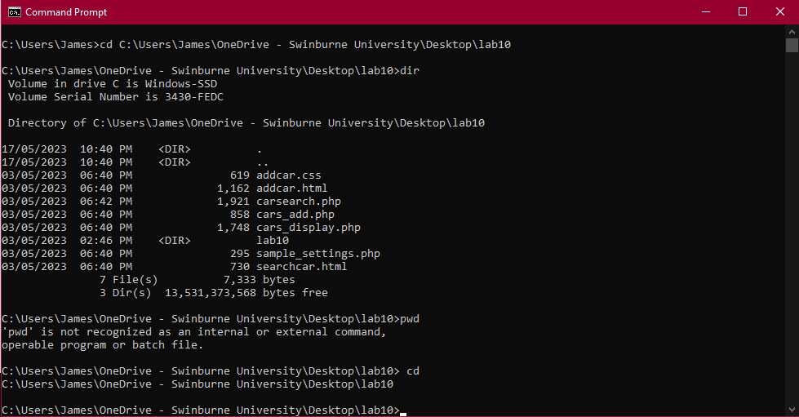Z

1. Consider the following kinds of information, and suggest the most appropriate data type to store or represent each:

|  |  |
| --- | --- |
| Information | Suggested Data Type |
| A person’s name | string |
| A person’s age in years | Integer |
| A phone number | String or integer |
| A temperature in Celsius | Float |
| The average age of a group of people | Integer |
| Whether a person has eaten lunch | Boolean |

1. Aside from the examples already given, come up with an example of information that could be stored as:

|  |  |
| --- | --- |
| Data type | Suggested Information |
| String | A locations name |
| Integer | Postcode |
| Float | Height in cm |
| Boolean | Is ‘A’ the first letter in the alphabet |

1. Fill out the following table, evaluating the value of each expression and identifying the data type the value is most likely to be:

|  |  |  |  |
| --- | --- | --- | --- |
| Expression | Given | Value | Data Type |
| 5 |  | 5 | Integer |
| True |  | True | Boolean |
| a | a = 2.5 | 2.5 | float |
| 1 + 2 * 3 |  | 7 | integer |
| a and False | a = True | True | Boolean |
| a or False | a = True | True | Boolean |
| a + b | a = 1  b = 2 | 3 | integer |
| 2 * a | a = 3 | 6 | integer |
| a * 2 + b | a = 1.5 b = 2 | 5 | integer |
| a + 2 * b | a = 1.5  b = 2 | 7 | integer |
| (a + b) * c | a = 1  b = 1  c = 5 | 5.5 | float |
| “Fred” + “ Smith” |  | “Fred Smith” | string |
| a + “ Smith” | a = “Wilma” | “Wilma Smith” | string |

1. Explain the difference between **declaring** and **initialising** a variable.

The difference between the two is declaring is used to specify the type of data for the variable, while initialising is used to set initial value to the variable.

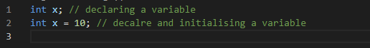

1. Explain the term **parameter**. Write some code that demonstrates a simple of use of a parameter.

A parameter is variable inside a function and it becomes an argument after passing to the function  
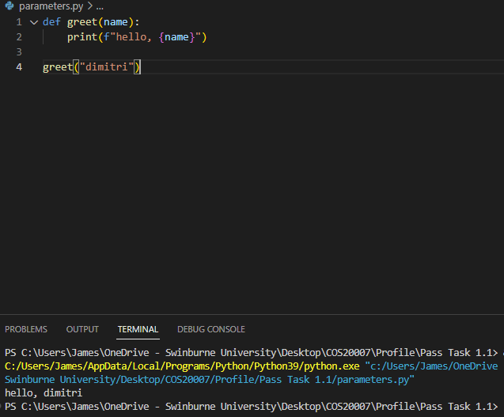

1. Using an example, describe the term **scope**.

Scope is where variables can be visible and accessible.

Example:

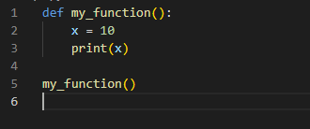

1. In any procedural language you like, write a function called Average, which accepts an array of integers and returns the average of those integers. Note — just write the function at this point, we’ll *use* it in the next task. You shouldn’t have a complete program or even code that outputs anything yet at the end of this task.
2. 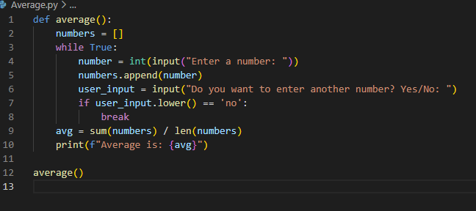 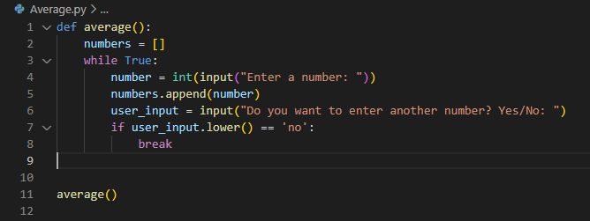In the same language, write the code you would need to call that function and print out the result.
3. To the code from 9, add code to print the message “Double digits” if the average is above 10. Otherwise, print the message “Single digits”.

*<insert a screenshot of your code here>  
<insert a screenshot of your whole program running here>*

